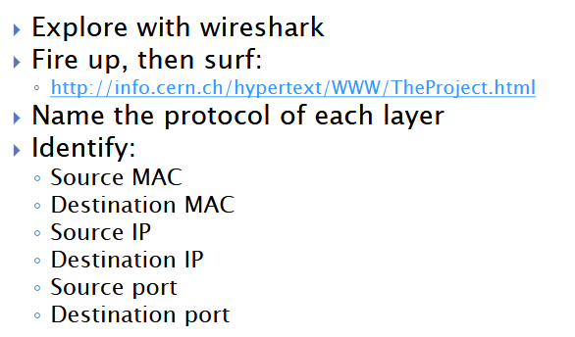  
  
Source mac & Destination mac:  
  
Source IP & Destination IP:  
